Macomb County students spend day off to help the homeless
- By Nicole Tuttle For Digital First Media
- Jan 17, 2019

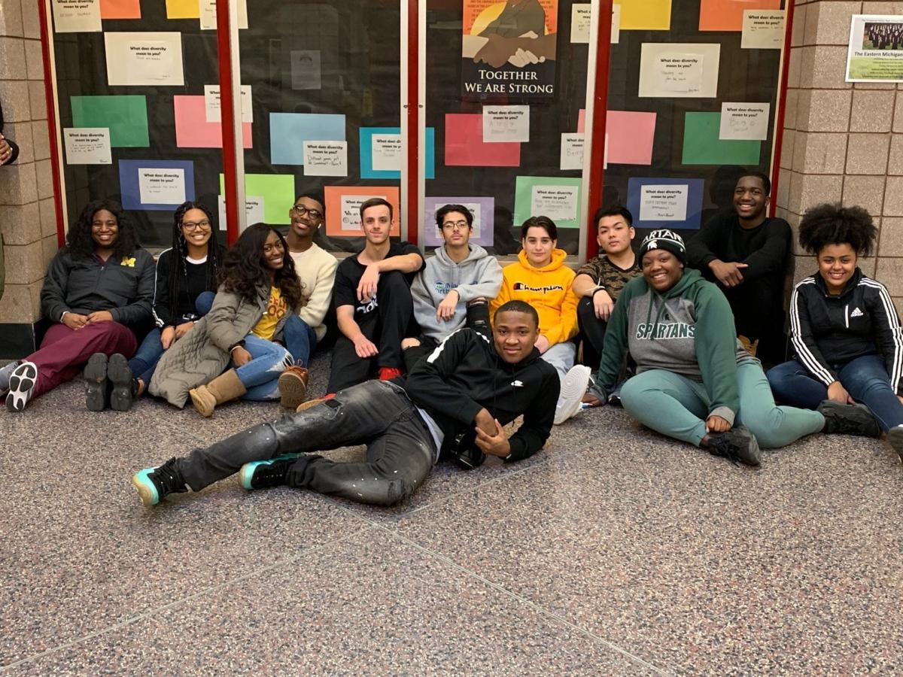

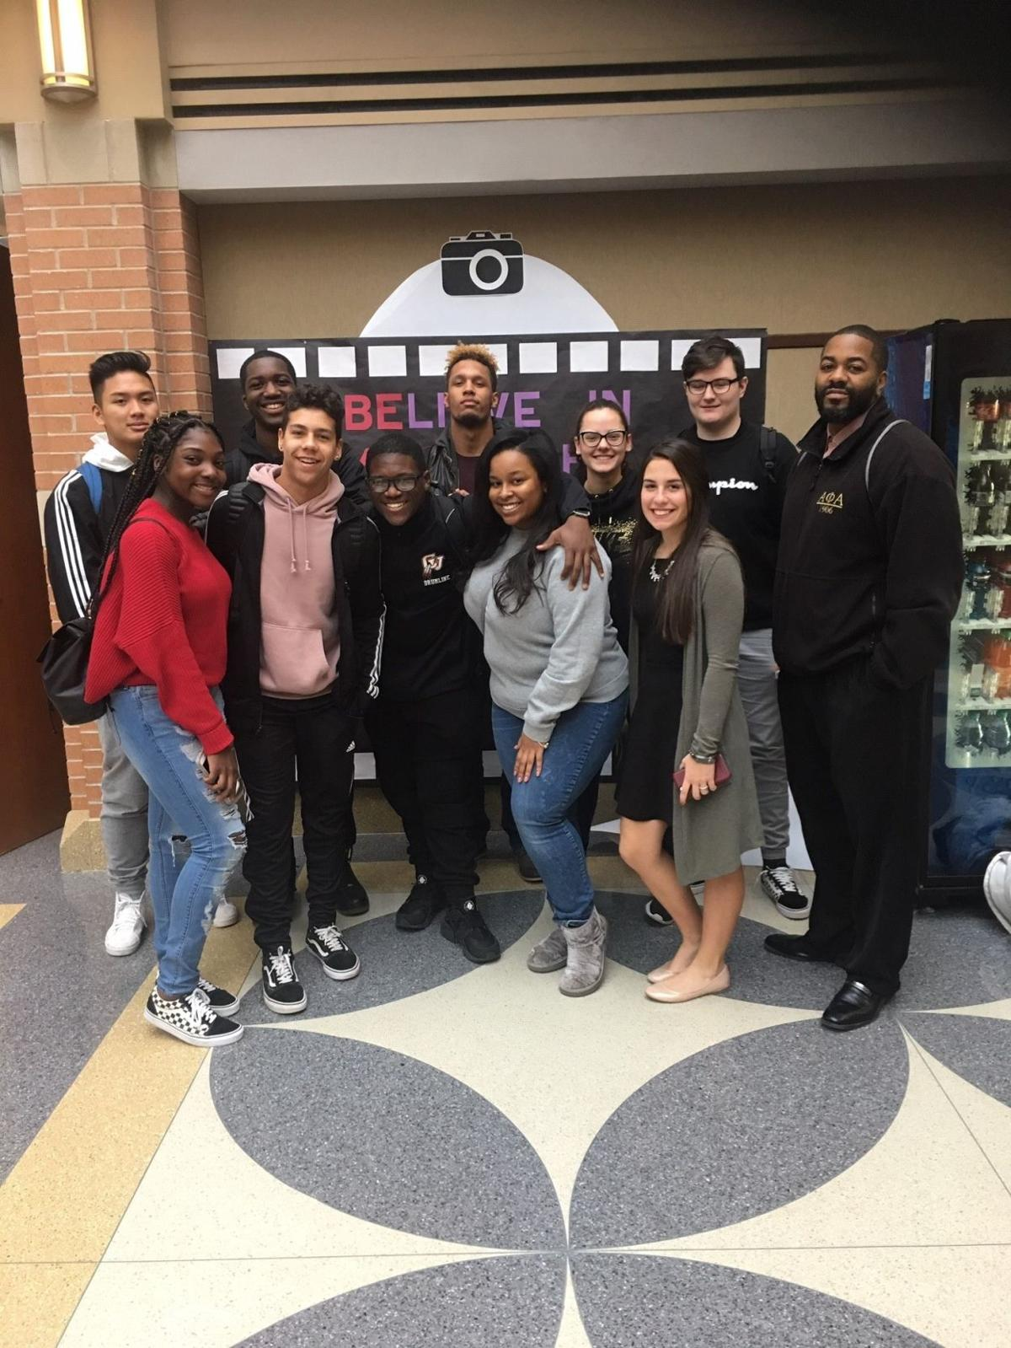

While many Macomb County students are enjoying a day off from school on Martin Luther King Day others will do work to honor the civil rights icon's legacy.
A group of Chippewa Valley High School students will be working to improve the plight of the homeless on Monday, Jan. 21.
The 30- 40 member group, Be The Change, is dedicated to student outreach and involvement. Aldo Holmes, an intervention specialist at Chippewa Valley High School, staff coordinator, said the group sets goals each month of performing community service, providing social events and providing information, awareness and understanding of varied student cultures.
Students had wanted to spend a day helping the homeless by serving coffee and donuts last year, but had difficulty finding an appropriate location. As a new staff coordinator for Be The Change, Holmes reached out to the Interfaith Center for Racial Justice in Mount Clemens and learned the church offers a food pantry and homeless assistance. It was the students themselves who volunteered to serve the coffee and donuts buffet style on Martin Luther King, Jr. Day, according to Holmes.
“On that day, the 21st, they have the day off that day, and they wanted to do something for student and community awareness, and out of kindness and consistency with Dr. King’s message,” Holmes said.
Since the church’s food pantry will also be open on Jan. 21, Holmes said students could also volunteer to assist with this in addition to the donuts, coffee and fellowship activity. Father Bob’s Food Shelf -- named for a reverend at the church who died in a car accident -- operates at Grace Episcopal Church on Mondays, Wednesdays and Fridays from 10 a.m. to noon.
“We have an outreach where we serve hot meals as well, but the food pantry is strictly emergency food,” Grace Episcopal Parish Administrator Donna Hodgson said.
The church also participates in Macomb County Rotating Emergency Shelter Team.
In the future, Chippewa Valley High School’s Be The Change group is planning activities for African-American History Month in February and for March is Reading month. An African-American female leadership panel is in the works for February and Be The Change students will read books by female authors to elementary school students in March, Holmes said.

