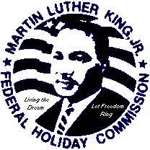
33rd Annual Dr. Martin Luther King Jr. Holiday Celebration
Of Macomb County
ICRJ Phone: 586/463-3675
Tyson House * 84 Beyne Street Fax: 586/469-0549
Mount Clemens, MI 48043 ,

Event Sponsorship
Diamond Sponsor ………………………………… …………………………. $5000
Platinum Sponsor …………………………………… ………………………. $2500
Gold Sponsor ………………………………………………………...………. $1500
Silver Sponsor………………………………………………………...………. $1000
Bronze Sponsor……………………………………………………...………… $750

Ad Descriptions
If possible, ads should be produced in PDF format and emailed to
mlk2020@att.net
Deadline for ad copy is December 30, 2019

Full Page $ 250 (8” x 9.5)
Half Page $150 (4.93” x 9.5”)

Dinner Ticket Reservation
Tables of 10 seats & Full-Page Ad …. $500 per table
Tables of 10 seats …. $350 per table
Dinner Tickets ………$40 each

